|  |  |  |  |  |  |
| --- | --- | --- | --- | --- | --- |
|  |  | |  | | --- | |  | | TRAVEL Check List | |  | |

# Passport/Visa/AIRLINE TICKETS

|  |  |
| --- | --- |
|  | PASSPORT |
|  | VISA CLEARANCE DOCUMENTS |
|  | AIRLINE TICKETS ( E - TICKETS ) |
|  | CURRENCY ( JAPANESE YEN ) |

# PRESENTATION AND POSTER SESSION MATERIALS

|  |  |
| --- | --- |
|  | PRESENTATION FILE ( RESEARCH ) |
| □ | PRESENTATION FILE ( INTRODUCING YOUR UNIVERSITY Engineering Education System ) SELECTED PRESENTERS ONLY |
|  | POSTER SESSION MATERIALS ( ONLY STUDENTS ARE REQUIRED ) |

# PROVIDING YOUR PRESENTATION WITH COMPUTER DEVICE

|  |  |
| --- | --- |
|  | SAVING YOUR PRESENTATION FILE IN A USB FLASH DRIVE |
| □ | SAING YOUR PRESENTATION FILE IN AN EXTERNAL HARD DISK DRIVE |
| □ | SAVING YOUR PRESENTATION FILE IN A LAPTOP COMPUTER |
|  | RECOMMENDED DEVICE FOR PRESENTAION: BRING YOUR LAPTOP COMPUTER |

# DOWNLORD FROM kait SYMPOSIUM WEB SITE

|  |  |
| --- | --- |
|  | HOW TO USE LIMOUSINE BUS SERVICE ( HANEDA / NARITA → HON-ASUGI STATION ) |
|  | AIRPORT LIMOUSINE BUS SCHEDULE ( HANEDA / NARITA → HON-ATSUGI STATION ) |
|  | HON-ATSUGI CITY MAP AROUND THE REMBRANDT HOTEL |
|  | JAPAN POWER PLUGS AND SOKETS |

# ELECTRICITY IN JAPAN

|  |  |
| --- | --- |
|  | POWER PLUG ADAPTER ( TYPE A JAPAN ) |
|  | VOLTAGE TRANSMITTER　 ( 100V JAPAN ) |

# HOTEL ROOM INTERNET ACCESS SERVICE ( THE REMBRANDT HOTEL ATSUGI )

|  |  |
| --- | --- |
|  | FREE INTERNET SERVICE ( WIFI AND LAN CABLE TYPE ) |

**Laptop PC Video Connection Port:**

**RGB Type OR HDMI Type**

When connecting to the projector display device for your presentation, only RGB or HDMI interface port is available to connect to the projector.

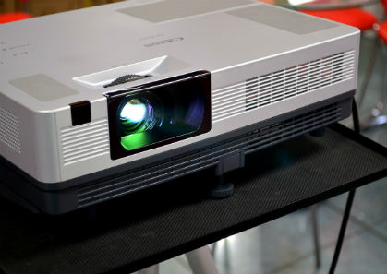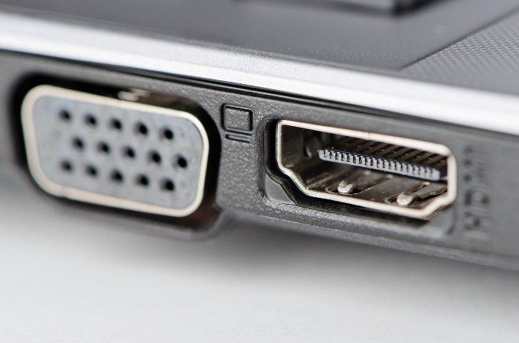

**Temperature in KANAGAWA Prefecture**  Average 26°C

September ushers in fall, which means the gradual decline of humidity and heat, but this month is also the darkest and wettest. Temperatures don't start dropping significantly until late September. Though the average high temperature is 26°C., it's not uncommon for temperatures to rise as high as 30 °C during the first few weeks of the month.